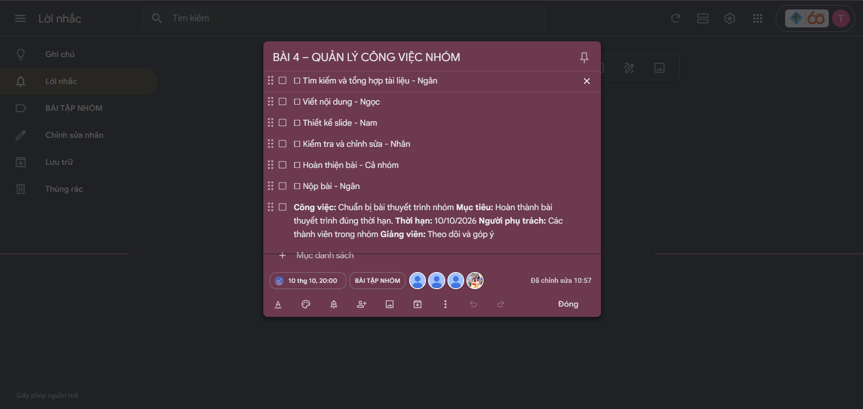
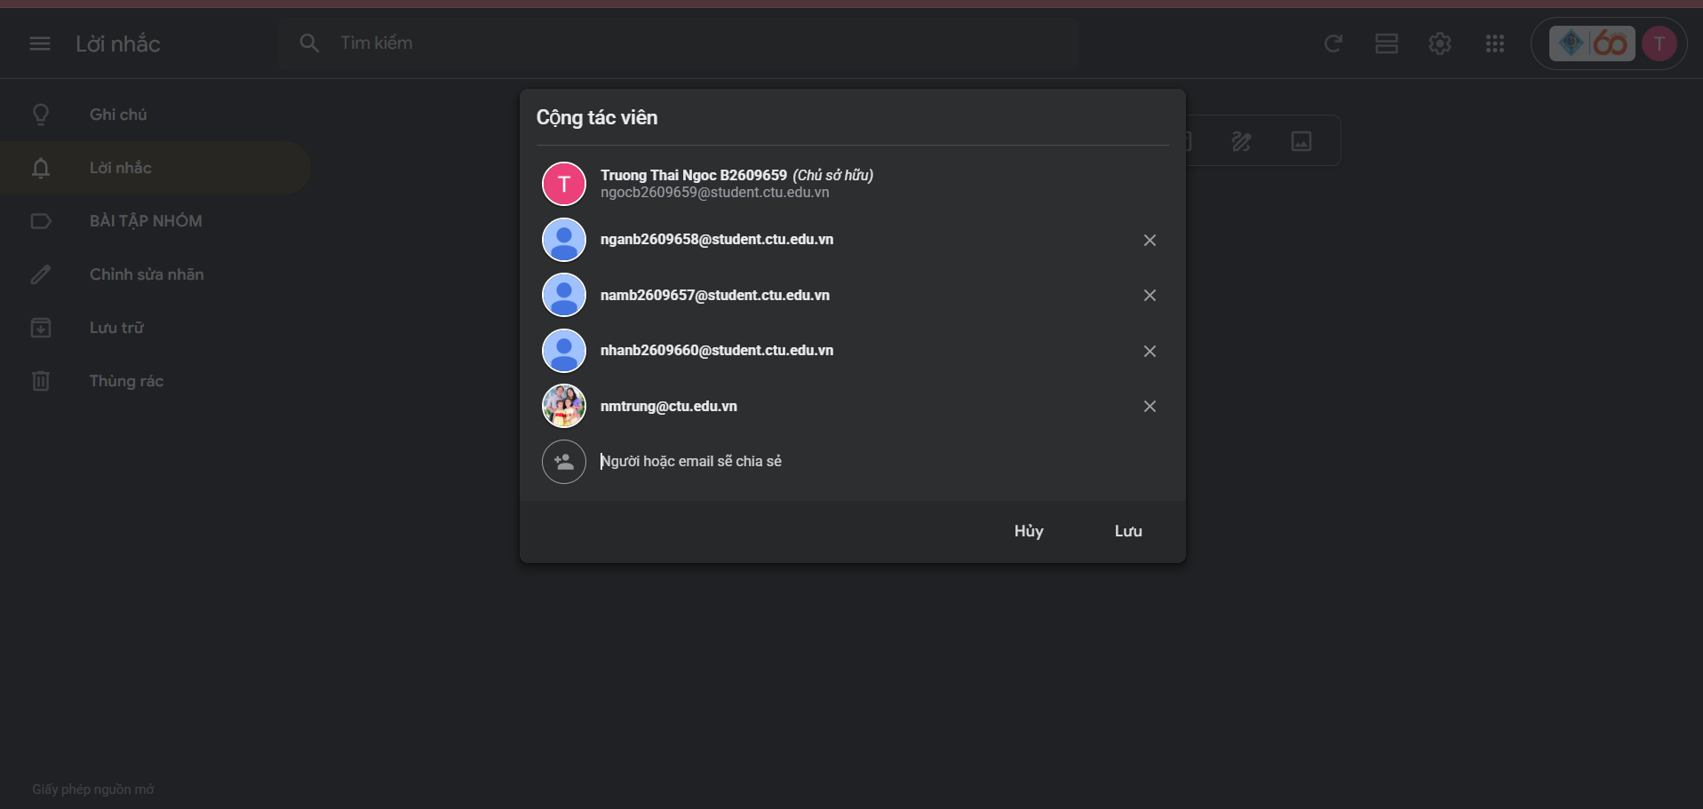
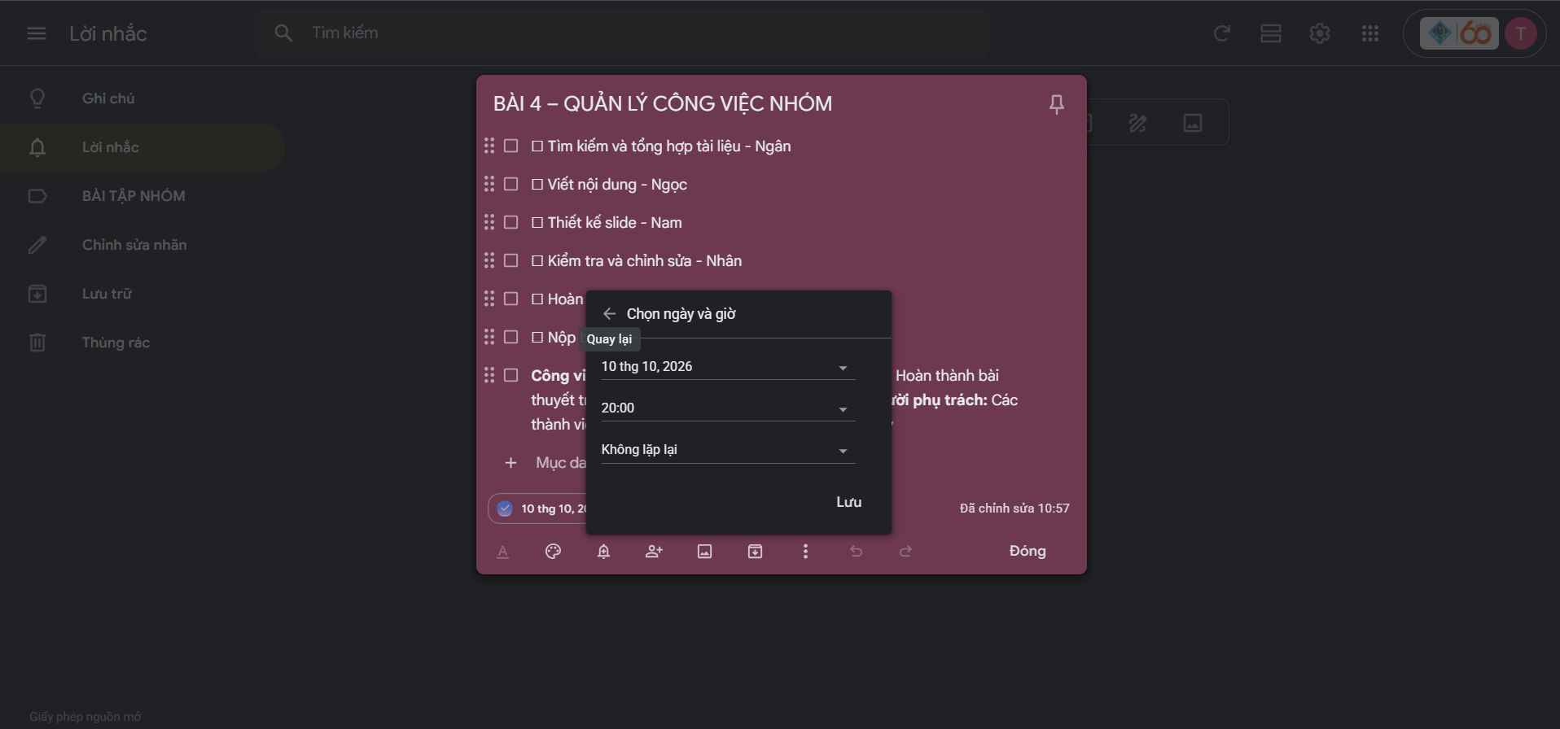

Gg keep: https://keep.google.com/u/0/#label/B%C3%80I%20T%E1%BA%ACP%20NH%C3%93M

